A low-cost sensor platform for measuring soil respiration

Patrick McCornack1, Renée Brown2

1Washington State University

2University of New Mexico

# Abstract

Soils are the largest terrestrial carbon pool and soil respiration is a significant source of atmospheric carbon. Soil respiration measurements are an important tool for quantifying gas exchange between soils and the atmosphere and for monitoring soil health and function. Respiration can be quantified by examining the change in soil CO2 concentrations over time.Autonomous sensors that measure soil CO2 concentrations are capable of capturing this temporal variability at fine resolutions that allow the assessment of respiration dynamics. However, the cost of these commercial-grade devices is high and this can limit their applicability. More data will be needed to determine whether these low-cost sensors are viable for scientific research, but preliminary data is promising. The sensors do appear to capture trends in soil respiration when compared with commercial sensors. By reducing equipment costs, this platform could potential opens the opportunity to expand the spatial coverage of soil respiration measurements which may offer new insights into the heterogeneity of soil processes.

# Introduction

Understanding terrestrial carbon dynamics is becoming increasingly important in the era of anthropogenic climate change. Soils store over twice as much carbon as the atmosphere, but they are also the second largest source of terrestrial carbon flux (Minasny et al., 2017**;** Bond-Lamberty & Thomson, 2010). Sequestering atmospheric carbon in soils has been suggested as a mechanism to offset anthropogenic carbon emissions as even a small increase in soil carbon stocks could have a large influence (Minasny et al., 2017). However, it is not well understood how carbon dynamics will be influenced by a changing climate. Soil respiration is sensitive to changes in temperature, variability in rainfall strength and timing, and has high spatial variability (Bond-Lamberty & Thomson, 2010**;** Vargas et al., 2012)**.** Climate models predict changes in temperature and precipitation regimes in the future, and it is anticipated soil carbon dynamics respond accordingly. Understanding how soils will react to different climate change scenarios will be important when considering soil management strategies to sequester carbon.

Soil respiration data provides insight about carbon flux in managed areas. This insight is necessary for managers to make informed decisions (Minasny et al., 2017). Automated CO2 sensors provide a means to collect high frequency data that is not labor intensive. Infrared gas analyzer (IRGA) devices provide high quality data on soil CO2 concentrations at a high temporal resolution (Vargas et al., 2012). High frequency data collection allows trends in soil respiration over time to be identified. These trends allow responses to environmental drivers such as changes in rainfall variability to be identified. The gradient method is one technique to calculate soil respiration from in-situ soil CO2 concentrations. This method provides information about the soil-atmosphere exchange as well as the soils vertical gas profile (Maier & Schack-Kirchner, 2014). However, IRGA devices are typically prohibitively expensive and multiple sensors are required when using the gradient method. This limits their potential applications and constrains the extent of the spatial resolution of soil respiration data.

To reduce cost barriers associated with soil respiration measurements, we developed a low-cost sensor platform for measuring soil respiration based on the SMAAC unit presented by Gyawali et al. (2019). The platform uses three low cost CO2 probes installed at different depths in the soil profile that record soil CO2 concentrations in-situ. Soil respiration and the vertical gas profile is then determined using the gradient method. The platform was deployed in an existing long-term rainfall manipulation experiment in the Sevilleta National Wildlife Refuge for the duration of the monsoon season. Data were compared with commercial IRGA CO2 probes to evaluate their suitability for scientific research.

# Materials and Methods

## Device

The sensor platform was based on the Soil Microbial Activity Assessment Contraption (SMAAC) presented by Gyawali et al. (2019). The SMAAC design was modified for long term field deployment to measure soil respiration using the gradient approach. The platform consisted of one Arduino Uno Microcontroller (Arduino LLC, Ivrea, Italy), one Adafruit Datalogger Shield (Adafruit Industries, New York, NY, United States), three Sandbox Electronics 10,000 ppm CO2 sensors (Sandbox Electronics, China), and two 10k ohm pull-up resistors.

The three CO2 sensors were wired in parallel in the prototyping area of the datalogging shield. Pull-up resistors were installed on the Serial Data Line (SDA) and Serial Clock Line (SCL) to minimize noise. Existing 12V solar infrastructure at the study site was used to power the platform through the barrel jack on the Uno.

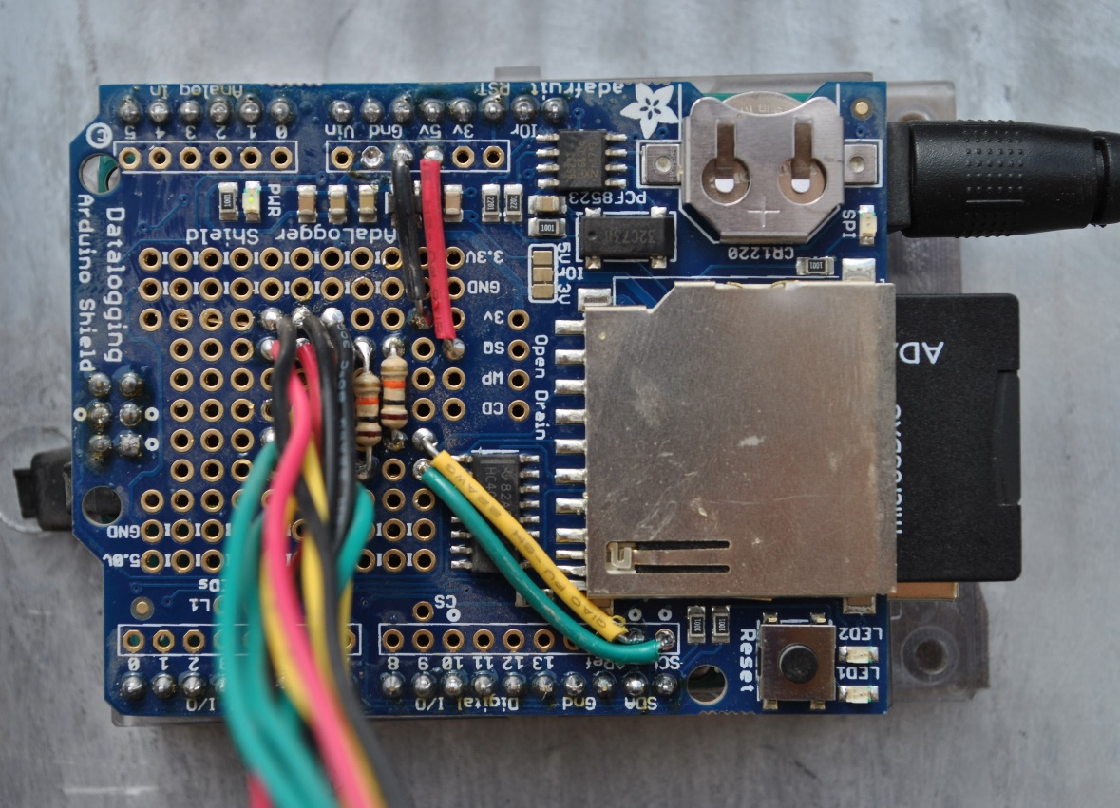

**Figure 1.** Sensor platform wiring. Wires of the same color are connected in parallel.

## Study Design

The sensor platform was deployed in a northern Chihuahuan Desert Grassland at the Monsoon Rainfall Manipulation Experiment (MRME; 34°20'38.75"N, 106°43'38.08"W), located in the Sevilleta National Wildlife Reserve. Established in 2007, MRME aims to evaluate the effect of precipitation variability on ecosystem processes, such as soil CO2 efflux, and has several plots that receive either monthly 20 mm rainfall addition events or weekly 5 mm rainfall addition events throughout the monsoon season (July-September). All plots receive ambient rainfall year-around. Each plot has three Vaisala CARBOCAP CO2 probes (GMM222, Vaisala, Helsinki, Finland) housed within a PVC array at depths of 2, 8, and 16 cm within the rooting zone of a clump of *Bouteloua eriopoda* (Vargas et al., 2011). These sensors measure soil CO2 concentration every 15 minutes, which is recorded by a CR1000 datalogger (Campbell Scientific Inc., Logan, Utah, USA). Soil temperature (CS107) is measured at 2 and 8 cm depths and soil moisture (CS616) is recorded as an integrated measurement of soil volumetric water content from 0-16 cm.

Our sensor platform was installed in one of the plots that receive an additional 5 mm precipitation on a weekly basis. The low-cost CO2 sensors were deployed in the same fashion as the existing probes in the rooting zone of a clump of *Bouteloua eriopoda* near the Vaisala probe array (Figure 2)*.* The sensors were wrapped in Gore-Tex cloth to protect against moisture and dirt while allowing gas exchange. The Arduino datalogger was installed in a weatherproof enclosure and powered by the 12V solar infrastructure.

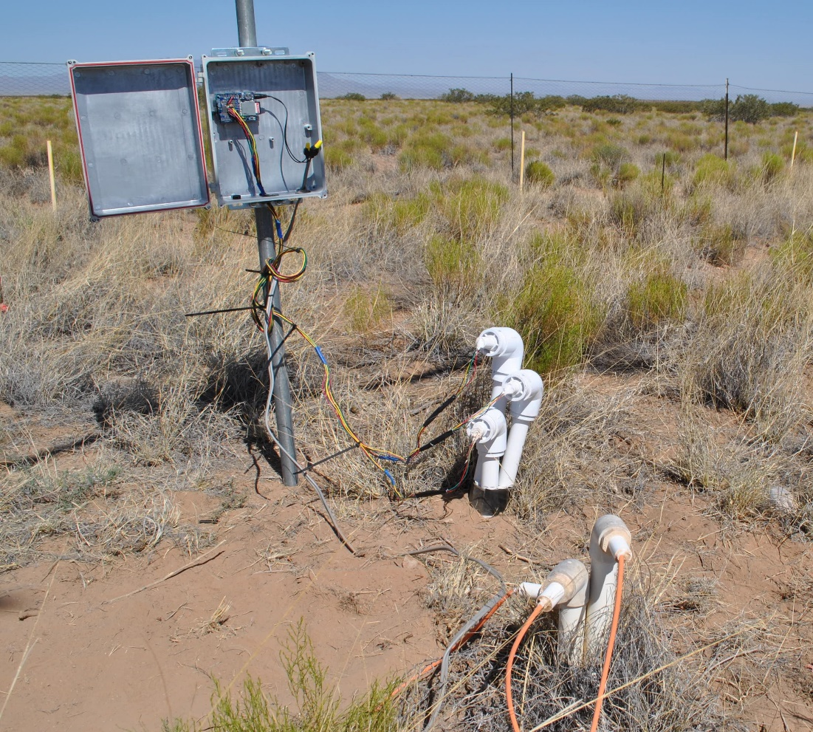

**Figure 2:** The field setup. The PVC array in the lower right houses the Vaisala probes while the Arduino datalogger and low-cost CO2 probe array are in the back.

## Data Analysis

The sensor platform will log soil CO2 concentrations in ppm from the 2, 8, and 16 cm probes at intervals of 15 minutes over the course of the monsoon season. These data will be compared with the soil CO2 concentration data generated by the Vaisala probes to determine how accurately the low-cost sensors were able to capture the soil carbon flux dynamics. All data analyses were performed in R version 4.0.0 (R Development Core Team, 20xx).

# Results

The low-cost sensors appear to capture some of the trends in CO2 data but the actual soil CO2 concentrations in parts per million (ppm) logged by the low-cost sensors do not fall within the 95% confidence interval of the average concentrations logged across all the plots (figure 1). These preliminary results suggest that the low-cost sensors are not accurate when compared with the commercial probes and therefore not suitable for scientific research. However, there is a high degree of variability among plots (figure 2). When compared with the data taken in the plot where the prototype has been deployed, the low-cost sensors do appear to follow the general trend (figure 3).

**Figure 3**: CO2 concentrations recorded by the low-cost sensors vs. 95% confidence interval of the average CO2 concentrations across all plots recorded by the commercial probes.

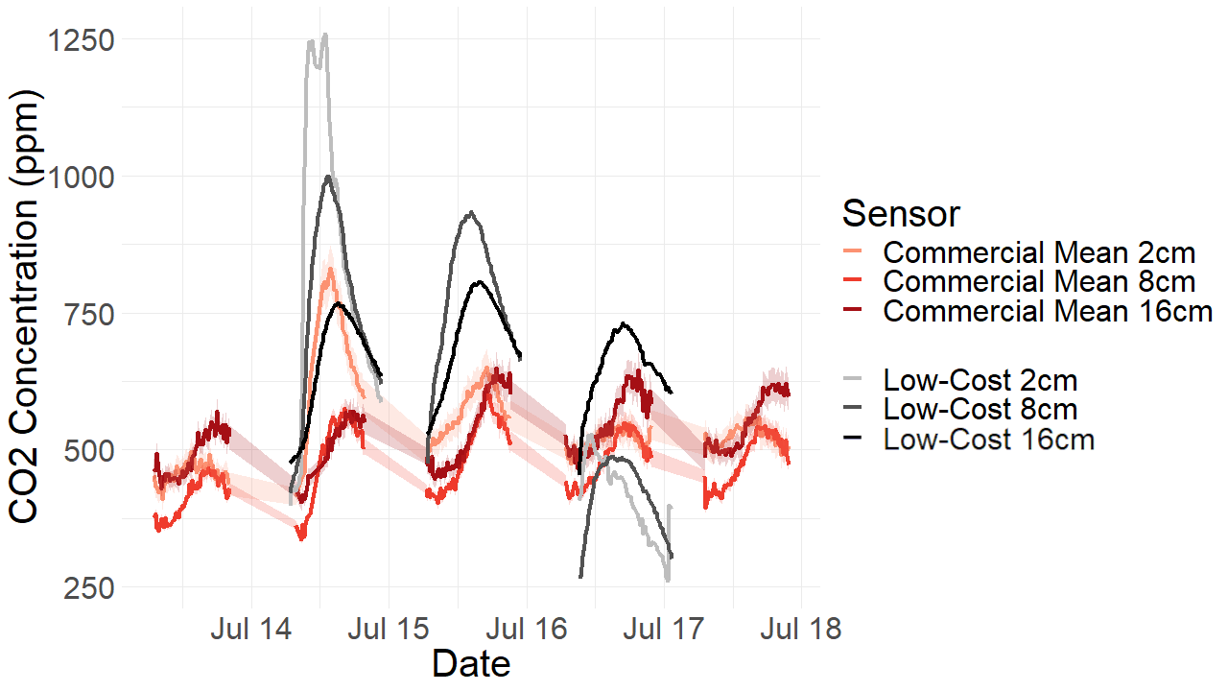

**Figure 4**: CO2 concentrations logged by all sensors in all plots. Plots are distinguished by color and sensor depth is distinguished by shade.

**Figure 5**: CO2 concentrations taken at plot on Thursday, July 23rd by the commercial and low-cost sensors.

# Discussion

Due to a series of issues that arose while deploying the prototype there is a paucity of data at this stage. These issues are largely related to unstable power problems at MRME that must be fixed before more data can be gathered. The preliminary data that has been gathered is promising however. In each figure, the low-cost sensors did appear to capture the trends in soil respiration throughout the day. This is more important than the actual concentration values themselves being the same as that is possibly a result of calibration differences. In figure 5, the 8cm and 16cm low-costs sensors captured the trend over the day exceptionally well. There is more variability occurring with the 2cm sensor, but that could be a result of more variability in microbial activity in the shallower layers of the soil.

Figure 3 shows the 95% confidence interval of the mean concentrations across all of the plots. The low-cost data fell outside of that interval by a large amount, but ultimately this comparison likely isn’t valid. As shown in figure 4, there is a high degree of variability among the plots at the site, so the average across all plots likely isn’t representative of what’s happening in the soil of plot 1 where the low-cost sensors are deployed. Additionally, there can be calibration differences among the probes that contribute to this discrepancy.

When looking at the trends in the data, the low-cost sensors have promise. More data will be needed to determine whether they are suitable for scientific application however. We currently plan to connect the datalogger to the solar infrastructure again once the power issues at MRME have been fixed. We then plan to collect data until the conclusion of the monsoon season in October. This low-cost sensor data will be compared with the data from the commercial probes over that time period to determine whether the evidence does support that these probes are suitable for research.

# References

Bond-Lamberty, B., & Thomson, A. (2010). Temperature-associated increases in the global soil respiration record. Nature Letters, 579-583.

Gyawali, A. J., Lester, B. J., & Stewart, R. D. (2019). Talking SMAAC: A new tool to measure soil respiration and microbial activity. Frontiers in Earth Science, 7, 1-8.

Maier, M., & Schack-Kirchner, H. (2014). Using the gradient method to determine soil gas flux: A review. Agricultural and Forest Meteorology, 78-95.

Minasny, B., Malone, B.P., McBratney, A.B., Angers, D.A., Arrouays, D., Chambers, A., Chaplot, V., Chen, Z., Cheng, K., Das, B.S., Field, D.J., Gimona, A., Hedl, C.B., Hong, S.K., Mandal, B., Marchant, B.P., Martin, M., McConkey, B.G., Mulder, V.L., O’Rourke, S., Richer-de-Forges, A.C., Odeh, I., Padarian, J., Paustian, K., Pan, G., Poggio, L., Savin, I., Stolbovoy, V., Stockmann, U., Sulaeman, Y., Tsui, C., Vagen, T., Vesemael, & B., Winowiecki, L. (2017). Soil carbon 4 per mille. Geoderma, 59-86.

Vargas, R., Collins, S. L., L, T. M., Johnson, J. E., Brown, R. F., Natvig, D. O., & Friggens, M. T. (2012). Precipitation variability and fire influence the temporal dynamics of soil CO2 efflux in an arid grassland. Global Change Biology, 1401-1411.